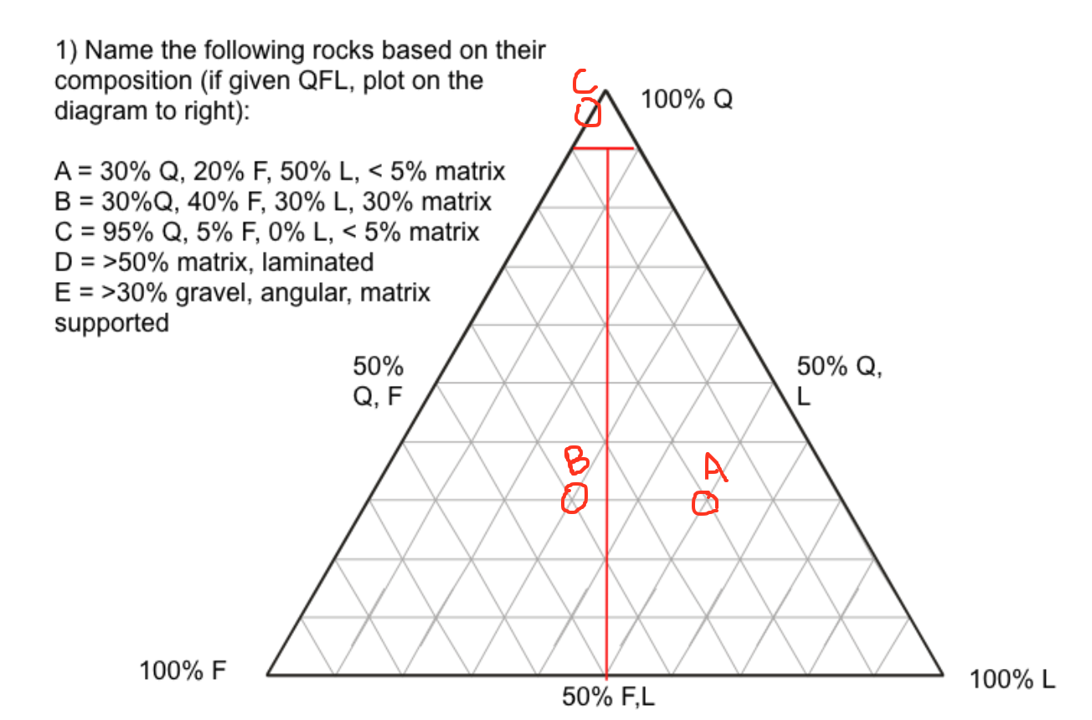

1. Above
   1. Lithic Arenite
   2. Feldspathic Wacke
   3. Quartz Arenite
   4. Shale
   5. Brecia
2. Ripples are 1cm to 10cm in relative height of each wavelength. Dunes can be anything greater than 10cm in height relative to wavelength, dunes can get up to 100s of meters.
3. Barchan dunes are also known as crescent dunes, these dunes form when there isn't very much sand and the wind is unidirectional. The tips of the dunes point downwind.
4. Tabular cross bedding the boundary layer surfaces are straight, unlike trough cross bedding the boundary surfaces are curved.
5. Looking at the two samples of LDPSA data you can tell that sample A, a beach sample which is predominately sand with mean and mode phi between 1-2, this shows that it is a more turbide environment with more energy, relatively well sorted, and seems to be more mature with sand due to the relatively small grain size, i.e. not pebbles or anything larger. Sample B, river environment, which is relatively not as well sorted with a wider variety of grain size with the histogram skewed to the right, the silts and clay would not be present in a beach environment with the waves keeping them suspended and not deposited, the grains seem to be mature as they are not pebble sized.
6. Major minerals found in siliciclastic rocks such as quartz, feldspars and lithic rocks.Major cements found could be quartz, chert, calcite, hematite among others.
7. Bedding ripple marks, tool marks and irregular bedding
   1. Ripple cross bedding, direction to right to left (<==)
   2. Roll marks or groove casts bedding plane marks, direction either right to left or left to right (<=>)
   3. Loading Casts or sole marks, direction left to right (==>)
8. Increasing stability: k-spar, plagioclase, quartz, zircon
9. The carbonate compensation depth is the water depth at which the rate of supply of calcium carbonate from the surface is equal to the rate of dissolution. Therefore no calcium is preserved. Shells of calcite precipitation dissolve and carbonate particles may not accumulate in the sediments on the sea floor below this depth
10. Both are orthochems, the micrite is microcrystalline calcite composed of carbonate mud, lime mud. Which can form needle shaped aragonite crystals, these are indicative of quiet water conditions. Spar, sparry calcite cement forms post deposition, large calcite crystals that fill interstitial pore spaces and cavities.
11. Peloids are rounded or oblong with no internal structure of fecal pellets. Ooids are spherical with a central nucleus that the ooid grows out from and forms growth lines.
12. Difference between telogenesis and eogenesis … early diagenesis (eogenesis), uplift-related diagenesis (telogenesis)
13. Stylolite consists of angular surfaces within a larger rock that a mineral material has been removed by pressure dissolution, in a deformation process that decreases the total volume of the rock.

Bonus

1. The Burgess Shale is a fossil-bearing deposit exposed in the Canadian Rockies of British Columbia, Canada which is known for its exceptional preservation
2. Uluru, also known as Ayers Rock, is a large sandstone formation situated in central Australia
3. The Miami Limestone, originally called Miami Oolite, is a geologic formation of limestone in southeastern Florida